**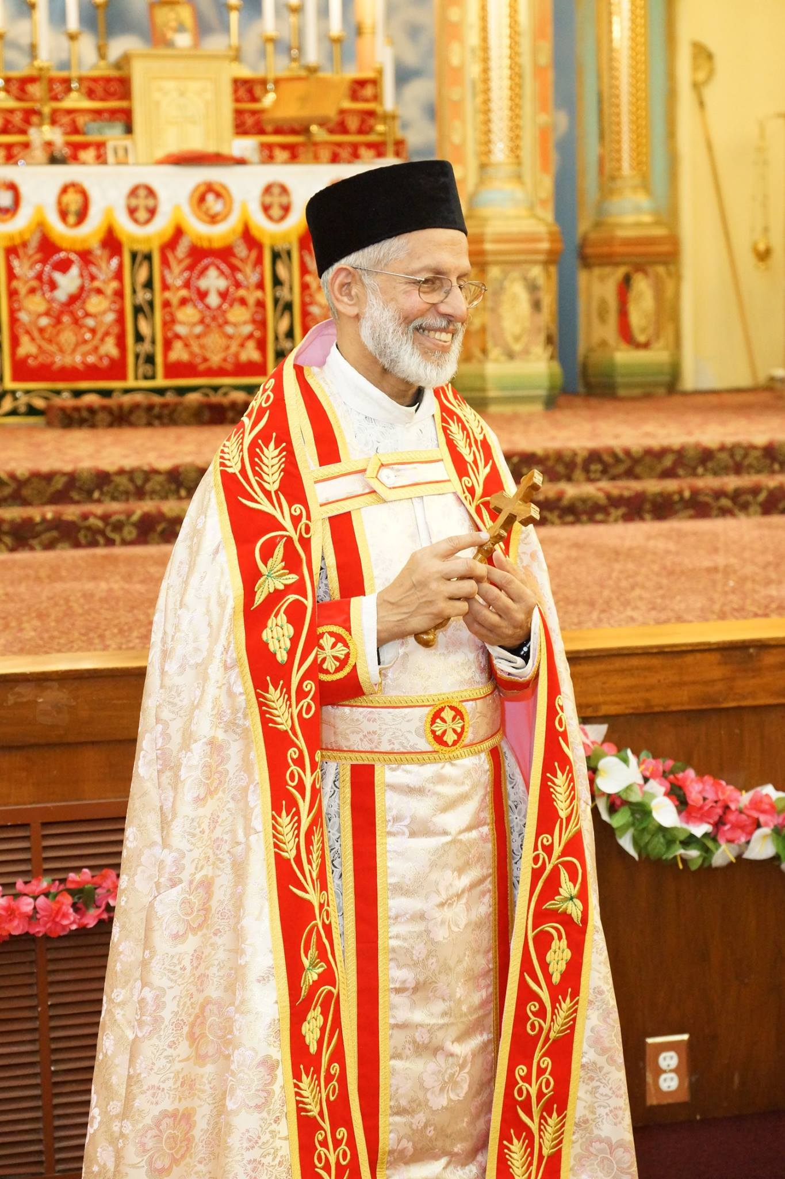****Vicar’s Message**

**MONTHLY NEWSLETTER**

**JANUARY 2025 VOLUME XXIX ISSUE 1**

## 

**ST. THOMAS INDIAN ORTHODOX CHURCH**

**1009 UNRUH AVE, PHILADELPHIA, PA 19111**

**Phone: (215) 342 1500 Fax: (215) 342 2700** [**www.stthomasphiladelphia.org**](http://www.stthomasphiladelphia.org)

**Welcoming the New Year**

By the grace of God, we have entered the New Year with hope and new mindset. Every year comes and goes whether we make any new resolutions or not. But it is an opportunity for us to revisit our mindset with new sense of dedication to the will of God. As time goes forward, our thinking pattern changes as new situations arise. Our situations of unhappiness, stress, disappointment, anger, joy, hope etc. are all subject to change from time to time. This is an indication that we are just ordinary human beings. Our situations make us what we are. Often smart people handle the situation positively and reset the mind to adjust to adversity. No matter how rich we are or how educated we are, or even how comfortable we are in a given situation, it is our ability to cope with the changing atmosphere that we succeed in our life. Sometimes even our comfort can make us go the wrong way.

It is highly essential for us to ponder on the great promise that the Lord gave us, “I will be with you to the end of the world.” Practically our world comes to an end when we pass from this life. That means the Lord’s promise is available to the end of our life. A believer banks on this promise in organizing his/her life acknowledging the divine presence in our midst. The Lord does not offer just comfort of the worldly kind. What He promises is just the enriching and encouraging presence with which we can go forward. In all our physical or spiritual activities, this promise of the Lord is relevant. He would not leave us orphans. Everything is a gift from God, and so our trust in the guidance of the Lord should be unwavering. When something adverse happens, do not be perplexed or disappointed. All adversities will change. We need just tolerance with trust in the power of the Lord who can change everything. Often, we try to change things in our own way which may end up in quarrel and feud. Whereas, if we seek the will of God, it will all be brought to our blessing.

St. Paul in all his adverse situations gained the promise from God, “My grace is sufficient for you”. Having done amazing service to the Lord, the Lord did not remove his ‘thorn in the flesh’. The same promise will be granted to us as well. “The Lord is my helper, I will not be afraid, what can man do to me? (Hebrews 13:6). The Immanuel who is born to us on Christmas, is powerful to control all matters if we are obedient. He will not forsake us.

In the New Year let us go forward with this hope.

Lovingly,

M.K. Kuriakosachan.

|  |
| --- |
| **COVID-19 and Support System**  **Financial Assistance to Members**  If any of our members need any assistance with food, medicine, transportation, shopping, or any other needs due to the COVID-19 pandemic, they may contact our Achens or the Secretary. They will coordinate help. Our MC members, along with other volunteers will be available to provide any possible help.  ***We are all in this together.***  **Contact**:   * Rev. Fr. M. K. Kuriakose: 201.681.1078 * Rev. Fr. Sujit Thomas: 516.754.0743 * Susan David: 518.362.6201 |

**2025 Leadership Team**

|  |  |
| --- | --- |
| **NAME** | **DESIGNATION** |
| Rev. Fr. M. K. Kuriakose | Vicar |
| Rev. Fr. Sujit Thomas | Assistant Vicar |
| Paul C. John | Treasurer |
| Susan David | Secretary |
| Varghese P. Abraham | Office Manager |
| Sherry Kurian | Assistant Secretary, Medical Team Lead |
| Reji Joshua Varghese | Assistant Treasurer - AR |
| Ajin Abraham | Ex-officio Treasurer, Asst. Treasurer – AR |
| John Panicker | Asst. Office Manager, Charity Coordinator, MOCF Rep |
| Rev. Dn. Predeep Chacko | Inventory Committee |
| Jobin Regi | Ex-officio Secretary, Inventory Committee |
| Sathees Easow | Refreshments Coordinator, MOCF Rep |
| Samkutty John | Refreshments Coordinator, Picnic/Sports Coordinator |
| Rajesh Geevarghese | Board of Trustees Member, Building Maintenance Coordinator |
| Thomaskutty Varghese | Building Upkeep Coordinator, Ecumenical Rep |
| Isac George (Bobby) | Board of Trustees Member, Library Coordinator |
| Nissi Zachariah | IT/Media Coordinator, Inventory Committee |
| Rachel David Melavila | Board of Trustees Member, Program Coordinator |

**Parish Highlights from December**

* December 7th – Ecumenical Fellowship of Indian Churches in Philadelphia (EFICP) conducted their 38th Ecumenical Christmas Day celebrations at George Washington High School, Philadelphia.
* December 14th and 21st – Christmas carolers led by our clergy and OCYM with participation of all spiritual organizations visited many of our parishioners’ homes.
* December 28th – Our Christmas Social was conducted with participation of all spiritual organizations and church members. Rev. Fr. Dr. Johnson C. Johnson, Vicar of St. Thomas Malankara Orthodox Church, Mascher St., gave the Christmas message.

**January Events and General Announcements**

**Church Reminders**

**Dip Jar:** Those who are interested in submitting their offertory or any other small donation may do so in the Church dip jar located by the Meditation Room.

**Digital Payment:**All donations may be made by Apple Pay / GPay / Venmo - members can scan QR codes affixed on the glass wall outside the Church office.

**Lost and Found:** Many small items such as jewelry and watches have been submitted to the office “Lost and Found”. Please see the Secretary if you believe you may be missing one of these items.

**Parish & Diocesan Events**

**January 8th –** Winter Summit was held at HTRC from Jan 8th to 11th. Main speaker was Rev. Fr. Shawn Thomas.

**January 18th** – New Year’s conference organized by Philadelphia Area MGOCSM was held at St. George, Fairless Hills, PA. Main speaker was Rev. Fr. Geevarghese John.

**March 1st** - Ecumenical Fellowship (EFICP) is hosting the World Day of Prayer on March 1st at 9 AM at our church.

**March 8th** - GROW One-Day Conference will be held at St. Stephen’s Orthodox Church, Midland Park, NJ.

**Spiritual Organization Updates**

**Men’s Forum**

* **2025 Office Bearers**:
  + Mr. Ninan Mathai – Secretary
  + Mr. Shibu Mathew - Treasurer
* Men’s Forum has weekly meetings after the Holy Qurbana every Sunday.

**MMVS**

* **2025 Office Bearers:**
  + Mrs. Jincy Abraham – Secretary
  + Mrs. Anitha Jossy – Treasurer
  + Mrs. Jolly Reji – Asst. Secretary
  + Mrs. Annamma Mathai – Asst. Treasurer
* MMVS Chitty will start February 1st.
* MMVS has weekly meetings after the Holy Qurbana every Sunday.

**Middle School Fellowship**

* CAYA Monthly Meeting was held at church on January 18th at 2 pm.

**MGOCSM**

* **2025 Office Bearers:**
  + Daniel Thomas - Secretary

**FOCUS**

* **2025 Office Bearer:**
  + Mr. Daniel George - Secretary
* The monthly FOCUS Meeting will be held on January 31st at church at 6:30 PM.

**OCYM**

* **2025 Office Bearers:**
  + Lins John – Secretary
  + Joel John Varghese – Jt. Secretary
  + Binsy Varghese – Vice President
  + Liya Thomas – Treasurer
  + Linda Aji – Jt. Treasurer
  + Alex Babu – Media

**OVBS**

* **Diocesan OVBS** is requesting submissions for songs,T-shirt designs, cover page designs, and skit or video messages
  + Deadline is Feb 14th
  + Please contact Sunday School Principal if interested

**Save the Dates**

**World Day of Prayer – March 1st**

**GROW Annual Conference - March 8th**

**Member Announcements**

**Birth Announcements**

|  |  |
| --- | --- |
| |  | | --- | | * December 10th - Baby Girl, Fiona Lijin, was born to parents Lijin and Donna Joyes and grandparents Joyce and Lally George (#362). | |

**Obituaries**

|  |  |
| --- | --- |
| |  | | --- | | * December 6th – **Mrs. Saramma Paulose,** mother of Rev. Fr. Eby Paulose passed away in Kerala. The funeral was held on December 7th. * December 18th – **Mr. Thomas John,** eldest brother of Mrs. Aleyamma Varghese (#143) passed away in India. The funeral was held on December 21st. * December 20th - **Mr. N. G. Abraham,** fatherof Abraham Geevarghese (#381) passed away in Kerala. The funeral was held on December 27th. * January 1st – **Rev. Fr. Dr. George Koshy** passed away in New York. The funeral was held on January 13. | |

***On behalf of the parish, we express our deepest condolences to the bereaving families. Let us pray for the departed souls and for the bereaving families. May our heavenly Father grant peace and comfort that surpasses human wisdom and understanding.***

**Memorial Prayer List**

As you know, members can submit names of departed loved ones that need to be included on the Memorial Prayer List. You probably have given the names of your departed ones in the past. However, please note that our church doesn’t have a system to save such names with dates or automatically track and decide on which Sunday the name should be included on the prayer list. You need to enter the name on the Memorial Prayer list kept in the church office. Note: We do have a master list of departed faithful that we keep for remembering them on the Sunday of the departed faithful, which is a week before the Holy Lent begins. This list has names only no dates.

**January Wedding Anniversaries**

Mr. & Mrs. Shibu Varghese Jan 1

Mr. & Mrs. Rajan T Samuel Jan 1

Mr. & Mrs. Eapen V Kalathil Jan 3

Mr. & Mrs. Shibu Mathew Jan 3

Mr. & Mrs. Lynnson Mathews Rajan Jan 3

Mr. & Mrs. Sam Jacob Kurisinmoottil Jan 4

Mr. & Mrs. Mathew Samuel Jan 5

Mr. & Mrs. Varghese Jacob Jan 5

Mr. & Mrs. Jaison Daniel Jan 5

Mr. & Mrs. Rev. Fr. Tojo Baby Jan 6

Mr. & Mrs. Mathew V Thomas Jan 6

Mr. & Mrs. Mathew Thankachan Jan 6

Mr. & Mrs. Tony Thomas Jan 6

Mr. & Mrs. C C John Jan 7

Mr. & Mrs. Anu Mathew Jan 9

Mr. & Mrs. Geevarghese K John Jan 9

Mr. & Mrs. Ninan Mathai Jan 9

Mr. & Mrs. Prasad George Jan 10

Mr. & Mrs. Oommen George Jan 11

Mr. & Mrs. Binu Thankachan Jan 11

Mr. & Mrs. Rinu John Jan 11

Mr. & Mrs. Lesley T Reji Jan 11

Mr. & Mrs. Elias K Issac Jan 12

Mr. & Mrs. Thomas Koshy Jan 12

Mr. & Mrs. George G Mampallil Jan 14

Mr. & Mrs. Thomas Zachariah Jan 15

Mr. & Mrs. Varghese K Issac Jan 16

Mr. & Mrs. James C Peter Jan 17

Mr. & Mrs. Philip Varghese Jan 18

Mr. & Mrs. Abraham Thomas Jan 19

Mr. & Mrs. Lukose Vaidyan Mathew Jan 23

Mr. & Mrs. Liju Cherian Jan 23

Mr. & Mrs. Liju Alex Jan 25

Mr. & Mrs. Rebu Roy Jan 26

Mr. & Mrs. Babu Varghese Jan 29



**January Birthdays**

**January 2023 VOLUME XXvII ISSUE 1**

Shine E Varghese Jan 1

Jestin K Abraham Jan 1

Abraham Thomas Jan 2

Aleena Robin Jan 2

Suja Abraham Jan 3

Roy Philip Chacko Jan 4

Deepu Mathew Daji Jan 2

Renju Ann Joy Jan 5

Chrislin H Thomas Jan 5

Jobin Varghese Jan 5

Ron Philip Jan 5

Lydiya Elsa Jaison Jan 6

Jijo Jacob Jan 6

Diya Sara Thomas Jan 6

Madeline John Jan 7

Amelia J Mathew Jan 7

Wilson Panicker Jan 7

Joyel Manoj Jan 8

Anila Thomas Jan 8

Mini Ninan Jan 9

Marshel Varghese Jan 9

Isha Mariam Alex Jan 9

Andrew Cherian Jan 9

Nivitha Wilson Jan 10

Sandeep K Thomson Jan 10

Johan Ajish Jan 11

Divya Mary Thomas Jan 12

Harshall Thomas Jan 12

Carolyn Thomas Jan 13

Rachael Thomas Jan 13

Joshua M George Jan 13

Shawn George Philip Jan 13

Rijon C Simon Jan 14

Shelby K Renji Jan 14

Ramany George Jan 15

Ian Thomas Jan 15

Allen Abraham Jan 16

Susan Jency Jacob Jan 16

Sajan Varughese Jan 16

Amryn James Jan 16

Binsy Mathew Jan 17

Adam M Anu Jan 17

Maliyil M Philip Jan 18

Sanju John Jan 19

Wincy B Joseph Jan 20

John Polayil Abraham Jan 21

Mammana Unmesh Jan 21

Maria Anna Abraham Jan 21

Anu Lajy Jan 21

Christopher Nelson Jan 22

Susan John Jan 22

Sunil Thomas Jan 23

Anu Mathew Jan 23

Shiji Mathew Abraham Jan 23

Shannon Ann George Jan 23

Alwin T Raju Jan 23

Jelitta James Jan 24

Paulson Avarachan Jan 24

Linju Jacob John Jan 25

Noah Paul Vergis Jan 25

Angelin Shibu Mathew Jan 26

Saramma Thomas Jan 27

Kasen Samuel Lajy Jan 27

Mathew Thankachan Jan 28

Susan Mathew Jan 28

Mathew Philip Jan 30

Abraham M Thomas Jan 30

Thomas Abraham Jan 31

Christin Thomas Jan 31

**Sunday School News**

**January 2023 VOLUME XXvII ISSUE 1**

*Submitted by Steven Kurian, Principal*

*Tel.: 267.450.6815, Email:* [*stevekurian@gmail.com*](mailto:stevekurian@gmail.com)

**One Year Bible Reading Schedule - January**

|  |  |  |  |
| --- | --- | --- | --- |
| **Date** | **I** | **II** | **III** |
| **January 1** | Genesis 1-2 | Psalms 1-2 | Matthew 1-2 |
| **January 2** | Genesis 3-4 | Psalms 3-5 | Matthew 3-4 |
| **January 3** | Genesis 5-6 | Psalms 6-8 | Matthew 5 |
| **January 4** | Genesis 7-8 | Psalms 9-10 | Matthew 6 |
| **January 5** | Genesis 9-10 | Psalms 11-13 | Matthew 7 |
| **January 6** | Genesis 11-12 | Psalms 14-16 | Matthew 8 |
| **January 7** | Genesis 13-14 | Psalms 17 | Matthew 9 |
| **January 8** | Genesis 15-16 | Psalms 18 | Matthew 10 |
| **January 9** | Genesis 17-18 | Psalms 19-21 | Matthew 11 |
| **January 10** | Genesis 19 | Psalms 22 | Matthew 12 |
| **January 11** | Genesis 20-21 | Psalms 23-25 | Matthew 13 |
| **January 12** | Genesis 22-23 | Psalms 26-28 | Matthew 14 |
| **January 13** | Genesis 24 | Psalms 29-30 | Matthew 15 |
| **January 14** | Genesis 25-26 | Psalms 31 | Matthew 16 |
| **January 15** | Genesis 27 | Psalms 32 | Matthew 17 |
| **January 16** | Genesis 28-29 | Psalms 33 | Matthew 18 |
| **January 17** | Genesis 30 | Psalms 34 | Matthew 19 |
| **January 18** | Genesis 31 | Psalms 35 | Matthew 20 |
| **January 19** | Genesis 32-33 | Psalms 36 | Matthew 21 |
| **January 20** | Genesis 34-35 | Psalms 37 | Matthew 22 |
| **January 21** | Genesis 36 | Psalms 38 | Matthew 23 |
| **January 22** | Genesis 37 | Psalms 39-40 | Matthew 24 |
| **January 23** | Genesis 38 | Psalms 41-43 | Matthew 25 |
| **January 24** | Genesis 39-40 | Psalms 44 | Matthew 26 |
| **January 25** | Genesis 41 | Psalms 45 | Matthew 27 |
| **January 26** | Genesis 42-43 | Psalms 46-48 | Matthew 28 |
| **January 27** | Genesis 44-45 | Psalms 49 | Romans 1-2 |
| **January 28** | Genesis 46-47 | Psalms 50 | Romans 3-4 |
| **January 29** | Genesis 48-50 | Psalms 51-52 | Romans 5-6 |
| **January 30** | Exodus 1-2 | Psalms 53-55 | Romans 7-8 |
| **January 31** | Exodus 3-4 | Psalms 56-57 | Romans 9 |

**Please remember to keep the Sunday School Children and Staff in your daily prayers.**